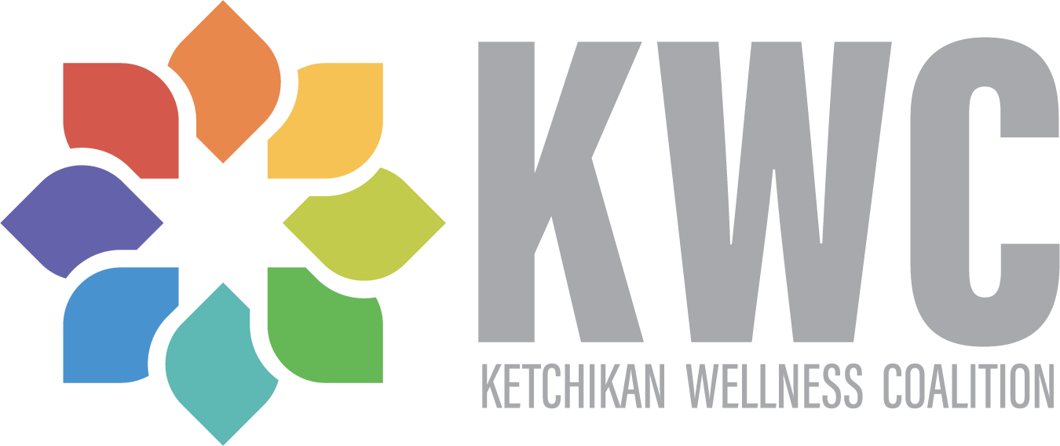

Ketchikan Wellness Coalition
602 Dock Street, Suite 108
Ketchikan, AK 99901

Greetings:

On behalf of the Ketchikan Wellness Coalition, please accept our appreciation for your interest in our organization. We would be honored for you to consider serving on our Governing Board.

Governing Board members use their talents, knowledge, skills, and community contacts to help advance the Mission of the KWC. In return, we hope that our Board members feel personal rewards from the knowledge that their leadership and support make an important difference in Ketchikan.

We also hope that we can offer an enriching experience that will exceed personal and professional expectations.

The enclosed materials are intended to provide background information about the Ketchikan Wellness Coalition. Additionally, we are committed to spending time with you to personally answer your questions about the Board, our Task Forces, staff, and projects.

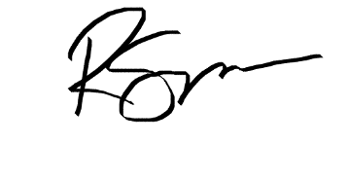
Sincerely,

Romanda Simpson
Executive Director & Behavioral Health Program Director
(907) 225-9355
romanda@ktnkwc.org

Mischa Chernick
Board President
board@ktnkwc.org

Governing Board Member Application

Name: ____________________________________Date: ____________________
Home Address: _____________________________________________________
Mailing Address: ____________________________________________________
Phone: ________________ Cell: ________________ Work: _______________
Email Address: _______________________________________________________
Employer: ___________________________________________________________
Professional Title: ____________________________

Mission: “Ketchikan Wellness Coalition promotes community wellness through assessment and action.”
Vision: “Establish Ketchikan as a vibrant (healthy) community that people choose to live in.”

- Why are you interested in KWC Governing Board?
__________________________________________________________________
__________________________________________________________________

- What other community agencies/organizations are you involved with or have been in the past?
__________________________________________________________________
__________________________________________________________________
- Do you feel you have significant investment of time, talent, affinity, and treasure to further the purpose of the KWC?
__________________________________________________________________
__________________________________________________________________

- Are you able to attend regular monthly Governing Board meetings and participate in annual fundraisers? YES__ NO__

Education and Professional Experience:
__Business __Labor __Community Service
__Finance __Education __Legal
__Non-Profit __Government __Consultant

Areas of Expertise, Skill, and Interest:
__Spiritual Leadership __Building/Facilities __Financial Management
__Social Work __Strategic Planning __Legal
__Organizational Devel. __Public Relations __Volunteer Management
__Board Development __Marketing __Event Planning
__Personnel __Fundraising __Other_____________

Thank you for completing this application.
Ketchikan Wellness Coalition Mission and Vision

Mission. KWC’s mission is to promote community wellness through assessment and action.

Vision. The vision is to establish Ketchikan as a vibrant (healthy) community that people choose to live in.

KWC Core Values

Evidence Based. We move forward with knowledge. Our actions are based on evidence and research into what works to address specific community concerns. We utilize assessment information to prioritize issues in our community and to evaluate the impact of our efforts. Our approaches are revised based on objective information.

Inclusive.We offer opportunities for structured contribution by anyone who shares our vision for a healthier community. We strive to connect enthusiastic community members with energizing and clear community roles.

Collaboration. While common goals and shared resources bring us together, cooperation, compromise, and shared leadership at all levels of the organization will bring about the best results.

Diversity. We believe that honoring diverse opinions and perspectives improves decision making and enhances the effectiveness of our work. We invite and respond to the voice and passion of everyone. We understand the power and importance of supporting voice among those most effected by the issues we are addressing. We take special care to solicit new perspectives and ideas from a wide variety of community members.

Integrity. Lead by example, keep commitments, make our actions match with our words, don’t expect more than you are willing to give. These basic credos provide a foundation for how we treat staff, contractors, volunteers, and community partners.

Sustainability. We seek to have a lasting impact on our community. On an organizational and program level, this means preserving the core values, achieving financial sustainability, building needed infrastructure, and inspiring enduring commitment. We adapt over time to thrive in changing circumstances.
About the Ketchikan Wellness Coalition

The Ketchikan Wellness Coalition was founded in 2007 by a group of passionate individuals and caring agencies considered the results of a community-wide survey. This group understood the value of working together, and that our problems could not be solved by any one person or organization. More, they knew the interconnectedness of these issues—the root causes of some of these social ills looked very similar to one another. The Ketchikan Wellness Coalition was born from this idea and formed as a 501(c)3 in 2008.

Today the KWC is a collection of different task forces, all focusing on a unique community issue:

- Behavioral Health Task Force
- Strengthening Cultural Unity
- Island Recycles
- Building a Healthy Community
- Substance Abuse Task Force
- Re Entry Coalition
- Imagination Library

Currently the KWC has five full-time staff, two part time staff, and are growing!

Our office is located downtown at 602 Dock Street #108. We also have a location at the Plaza Mall for a Youth Space and community use.

The organization is primarily financed through:

- A Drug-Free Communities Grant from the U.S. Department of Health and Human Services. The KWC is in its 8th year of a ten-year grant cycle. The Substance Abuse Task Force drives the work of this grant.
- A Comprehensive Prevention and Early Intervention Grant from the Alaska Division of Behavioral Health. KWC is in its second year of a three-year grant cycle.
- A State DHSS Reducing Recidivsm grant, in year two of a three-year cycle.
- A Robert Wood Johnson Foundation grant for Health Equity
- An Alaska Mental Health Trust grant for Crisis Now implementation
- A grant from the Ketchikan Gateway Borough for operating expenses.
- A grant from the City of Ketchikan for operating expenses.
- KWC has an individual and corporate membership program.

The Board Nomination and Recruitment Process

KWC believes that Board "prospecting" is an activity that should take place year-round. We primarily seek potential Board members who have knowledge, skills, abilities and community contacts that could help further KWC’s strategic initiatives.

Board prospects are invited to meet with the Executive Director and current Governing Board members. These meetings serve as an opportunity to get acquainted and answer questions that either party may have. These meetings are informal and are intended to help the Board prospect and the Board of Directors determine whether there is a good "fit."

When the Board and the Board prospect are in mutual agreement, a nomination occurs, and an election is held at the next full meeting of the Governing Board.

Governing Board and Staff

Governing Board

KWC is governed by a volunteer Governing Board comprised of volunteers providing leadership and strategic oversight. Our current members include:

President: Mischa Chernick
Vice-President: Abbie Stevenson
Treasurer: Grant Echohawk
Secretary: Dani Pratt
Members at Large: Austin Otos
Diane Gubatayao
Soohyun Kim
Erin Traudt
Kris Flora
Jennifer Bergen

Bookkeeper: Jay Johnson, CPA

KWC Staff

Executive Director: Romanda Simpson
Behavioral Health Program Coordinator: Kristen Van de Geer
Drug Free Communities Coordinator Deborah Asper
Health Equity Program Coordinator/ Alma Manabat Parker
Director of Operations:
ReEntry Coordinator Contractor: Steve Dempsey
Health Equity Program Assistant: Archie Inoncillo
Ketchikan123 Program Lead: Hilary Hartman
Office Clerk: Czarina Cabillo

KWC Governing Board Member Job Description and Expectations

Responsibilities:
- Attend at least 75% of scheduled meetings, which include regularly scheduled Governing Board meetings, special meetings called by the Chair, and special events sponsored by the Coalition.
- Stay informed about Coalition matters and come prepared for meetings and special events.
- Willing to be a committed and dedicated advocate for the KWC and its task forces.
- Give an annual contribution at a personally meaningful level (become a member).
- Support volunteer recruitment efforts by introducing potential business, organizations and individual community partners to the mission and vision of the KWC and assist in cultivating these relationships.
- Develop strategies for effectiveness and growth within the KWC strategic plan.
- Review performance of organization goals including: community wellness, fundraising, and budget.
- Serve on an ad hoc committee as needed. Terms of service on ad hoc committees will be discussed at time of committee development. All Ad Hoc committees will be developed as the Governing Board determines the need, and remain in place until the need is accomplished.
- If appropriate, act as a liaison between represented task force by sharing information including policies and procedures, ensuring task force alignment with KWC mission and vision, and sharing information from the task force to the Governing Board and Coalition Coordinator.

Anticipated Time Commitment: 4-6 hours per month
Monthly Governing Board meeting each fourth Tuesday at 5:30-7:00pm - 1½ hour
One Task Force meeting – 1 hour
One ad hoc committee meeting — 1 hour
Organizing, promoting, preparing/follow-up work outside of meetings – 1-3 hours

Qualifications:
- Demonstrate a passion for and dedicated to improving the status of health and wellness in Ketchikan.
- Be aware of and have access to individuals and organizations, which can be encouraged to participate and support the KWC.
- Moral, ethical, and personal conduct should align with the mission of the KWC.
- Demonstrate an understanding of a broad approach to improving health and wellness.

I acknowledge that I have read the above responsibilities and will commit to them to the best of my ability.

______________________ ______________________ ______________________
Printed name Signature Date

